Western University
Department of Modern Languages and Literatures

Writing and Composition
Fall 2023

TENTATIVE COURSE OUTLINE

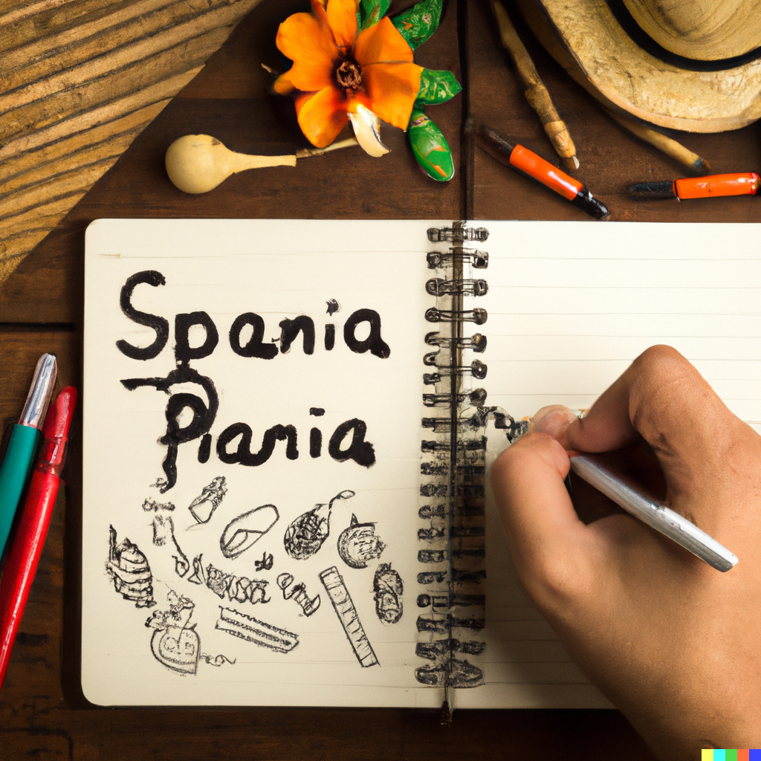
Writing and
Compostion in Spanish

Instructor: Alba Devo-Colis
Email: adevo@uwo.ca
Office: UC 4312
Office Hours: TBA
Class time: Tuesday 9:30-11:30
Location: UCC- 54B
Description of the course:
Drawing from a variety of engaging cultural and artistic expressions from the Hispanic World, this course focuses on developing syntactical and lexical usages, exploring writing techniques for organizing and presenting information, and for revising and editing. Students will review advanced grammatical structures in context to improve their written communication in Spanish.
Learning outcomes:
By the end of the course students will be able to:
- Use complex structures of the Spanish grammar
- Design, organize, and write academic and creative texts is Spanish
- Acquire cultural and artistic knowledge from the Hispanic World

Course calendar:

Week 1: Introduction to the course
Week 2: Punctuation and Syntax
Week 3: Description
Week 4: Narration
Week 5: Exposition I
Week 6: Exposition II
Week 7: Argumentation I
Week 8: Argumentation II
Week 9: Creative Writing I
Week 10: Creative Writing II
Week 11: Presentation of final project
Week 12: Final project due date

Please note:
This is a short version of the syllabus, which will be presented on the first day of class and uploaded to OWL.

